Level 3 Award in Wines mock tasting exam

Instructions for candidates

- For this examination you must describe and assess two still wines, one white and one red
- You may assess the wines in any order
- Write your descriptions and conclusions in the spaces provided
- You may NOT refer to notes or any other reference material (including the SAT)
- You have 30 minutes to complete the examination
- The marking keys are available online here: bit.ly/wine-lists-and-marking-keys

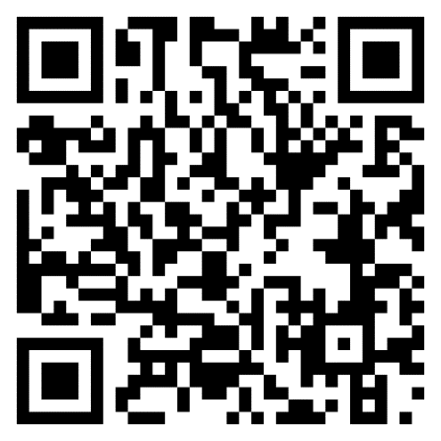

White Wine

Describe and assess the wine under the following headings.
Appearance 2 Marks

Nose For aroma descriptors there are a maximum of 5 marks available. Think in
terms of primary, secondary and tertiary as appropriate. 7 Marks

Palate For flavour descriptors there are a maximum of 3 marks available. Think in
terms of primary, secondary and tertiary as appropriate. 9 Marks

Assessment of quality 1 Mark

Readiness for drinking 1 Mark

Total 20 marks

Red Wine

Describe and assess the wine under the following headings.
Appearance 2 Marks

Nose For aroma descriptors there are a maximum of 5 marks available. Think in
terms of primary, secondary and tertiary as appropriate. 7 Marks

Palate For flavour descriptors there are a maximum of 3 marks available. Think in
terms of primary, secondary and tertiary as appropriate. 10 Marks

Assessment of quality 1 Mark

Readiness for drinking 1 Mark

Total 21 marks

TOTAL MARKS FOR BOTH WINES_____________

